1. # The following line won't run because of a syntax error

print("hi)

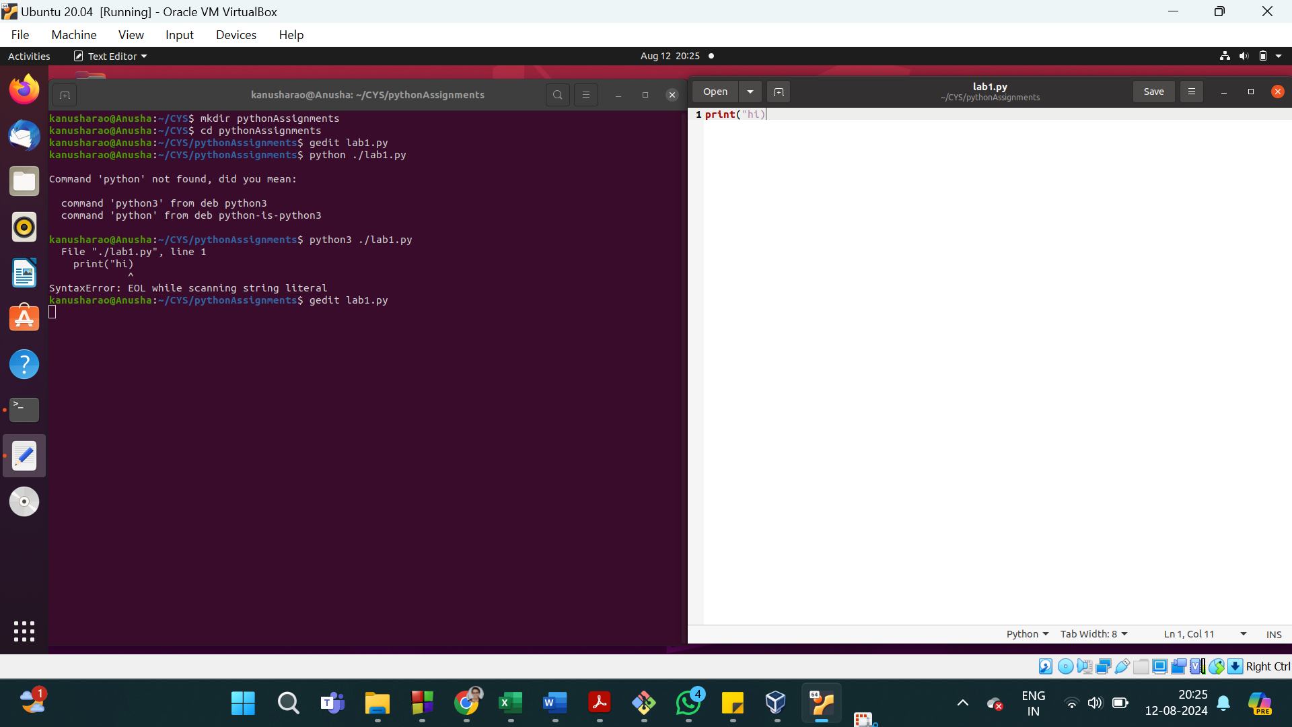

2. # Exercise 2

''' The following lines won't run properly,

even if the syntax error in the line above is corrected,

because of a run-time error '''

print(hello)

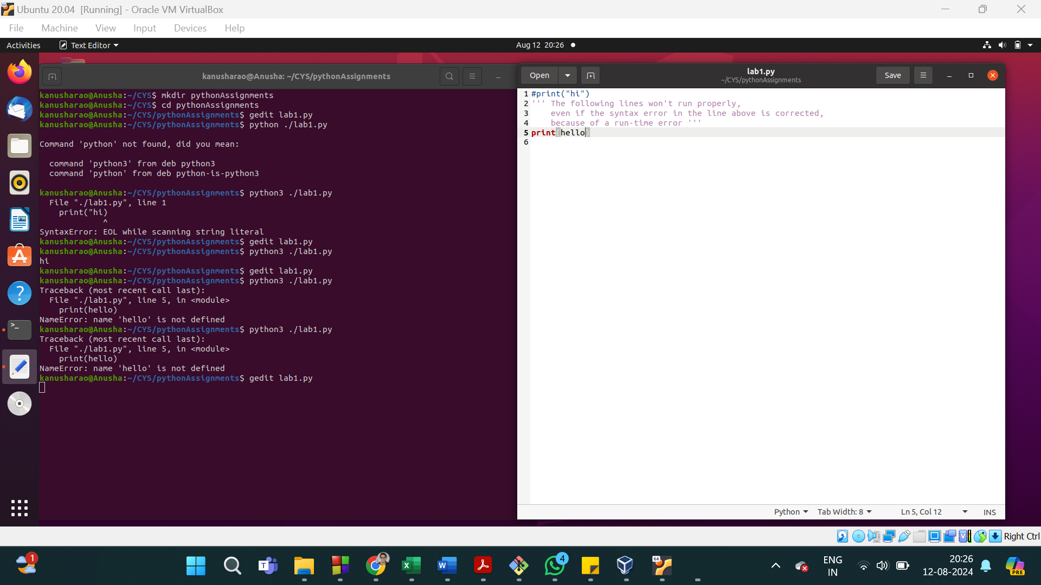

3. # Display a string (greeting message) directly

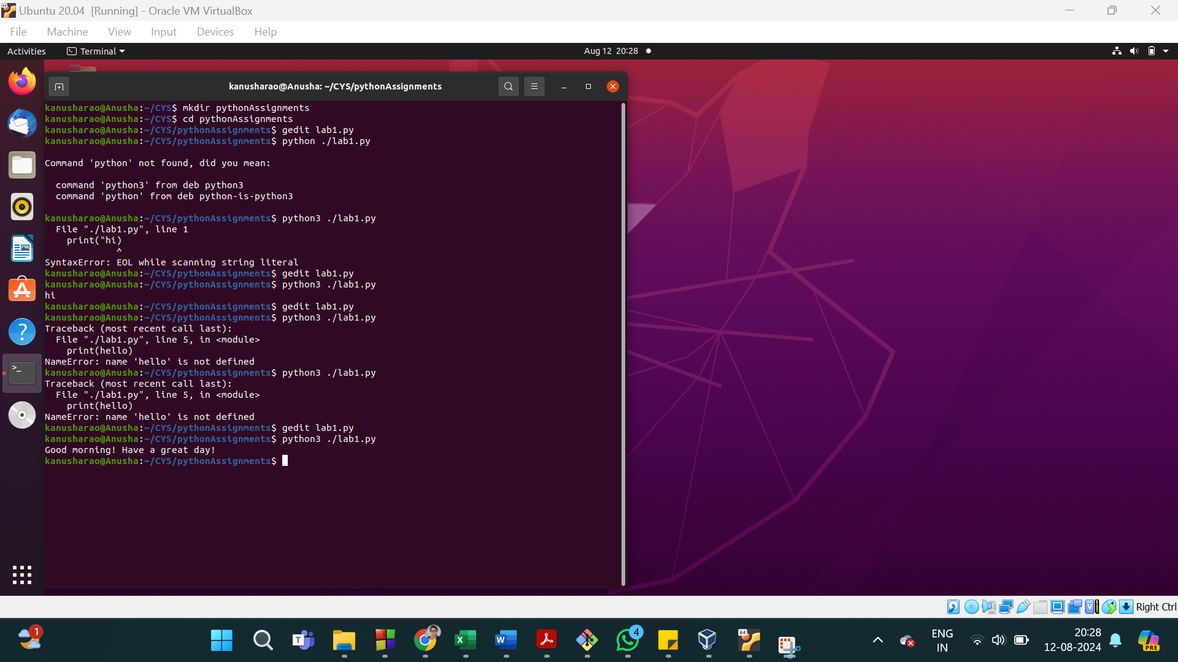

4. # Display the contents of a string variable

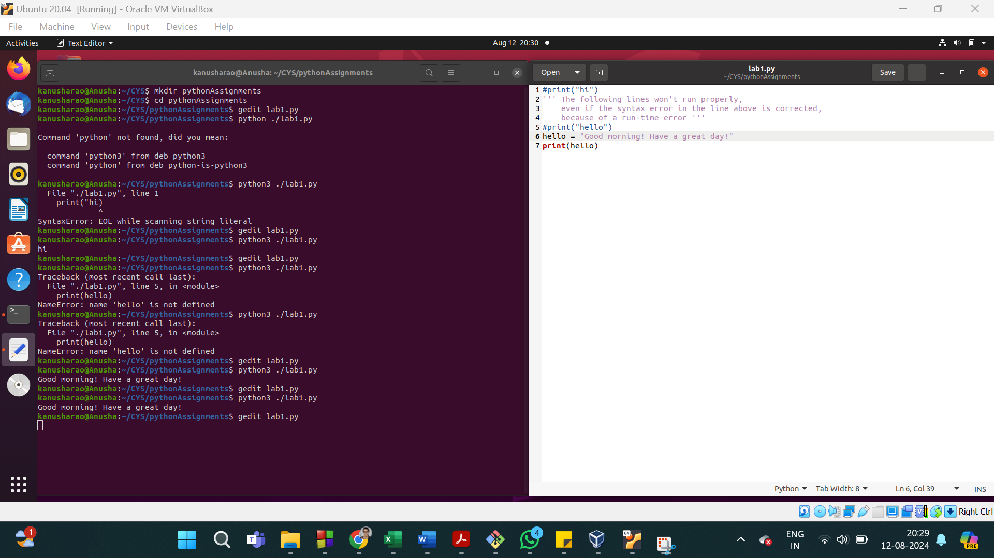

5. # Display the string which contains single quotes

Ex: Indian's

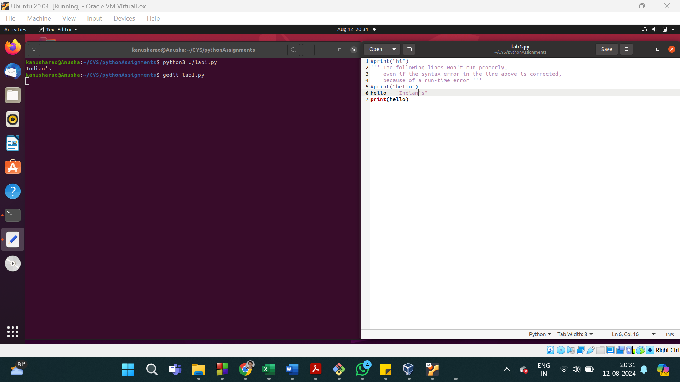

6. # Display the string which contains Double Quotes

Ex: Students,"Welcome to SOIS".

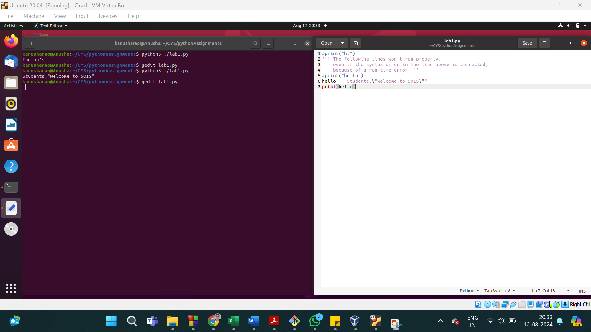

6. Read two numbers in (user input) and store as num1 and num2, Calculate the sum, difference, product, Quotient, reminder, power

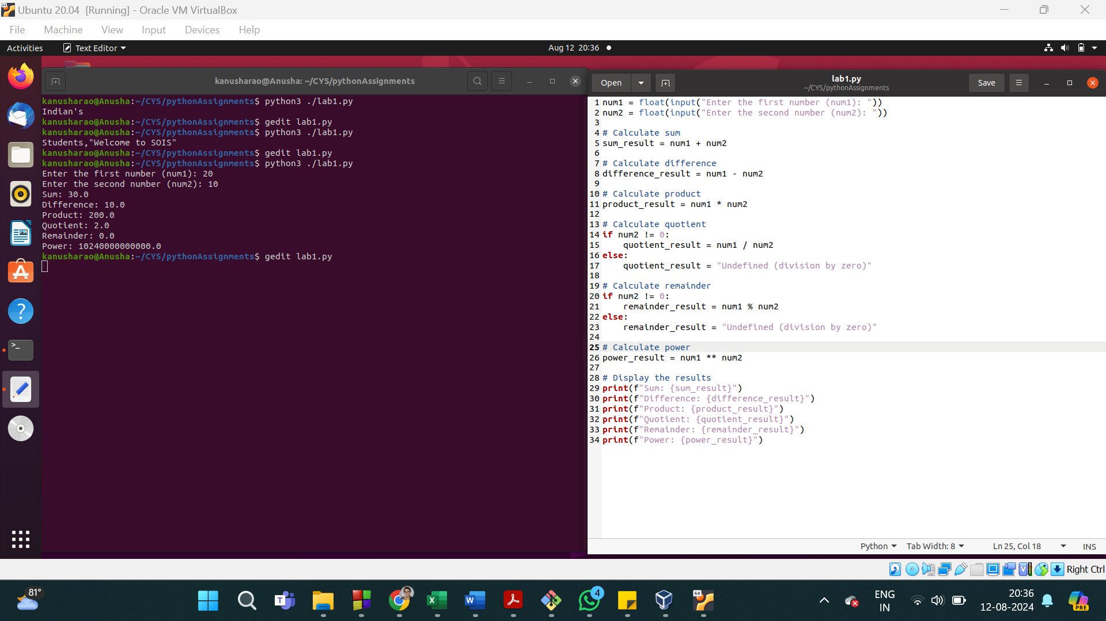

7. check the value of num1 is integer or not?

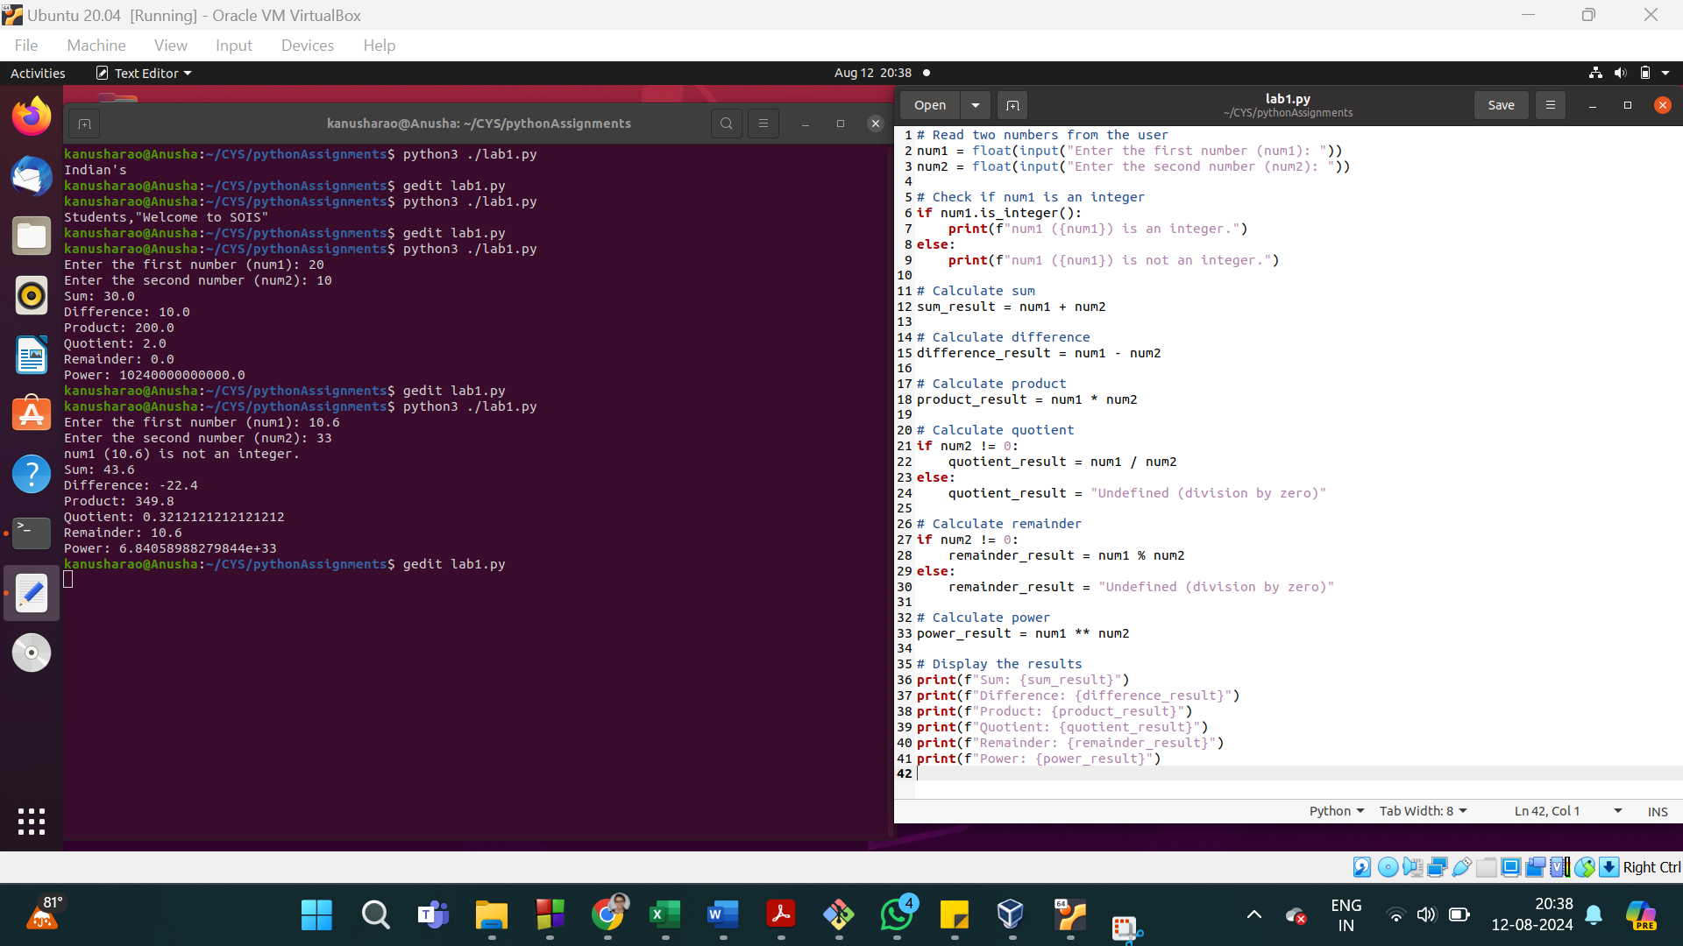

8. convert into integer

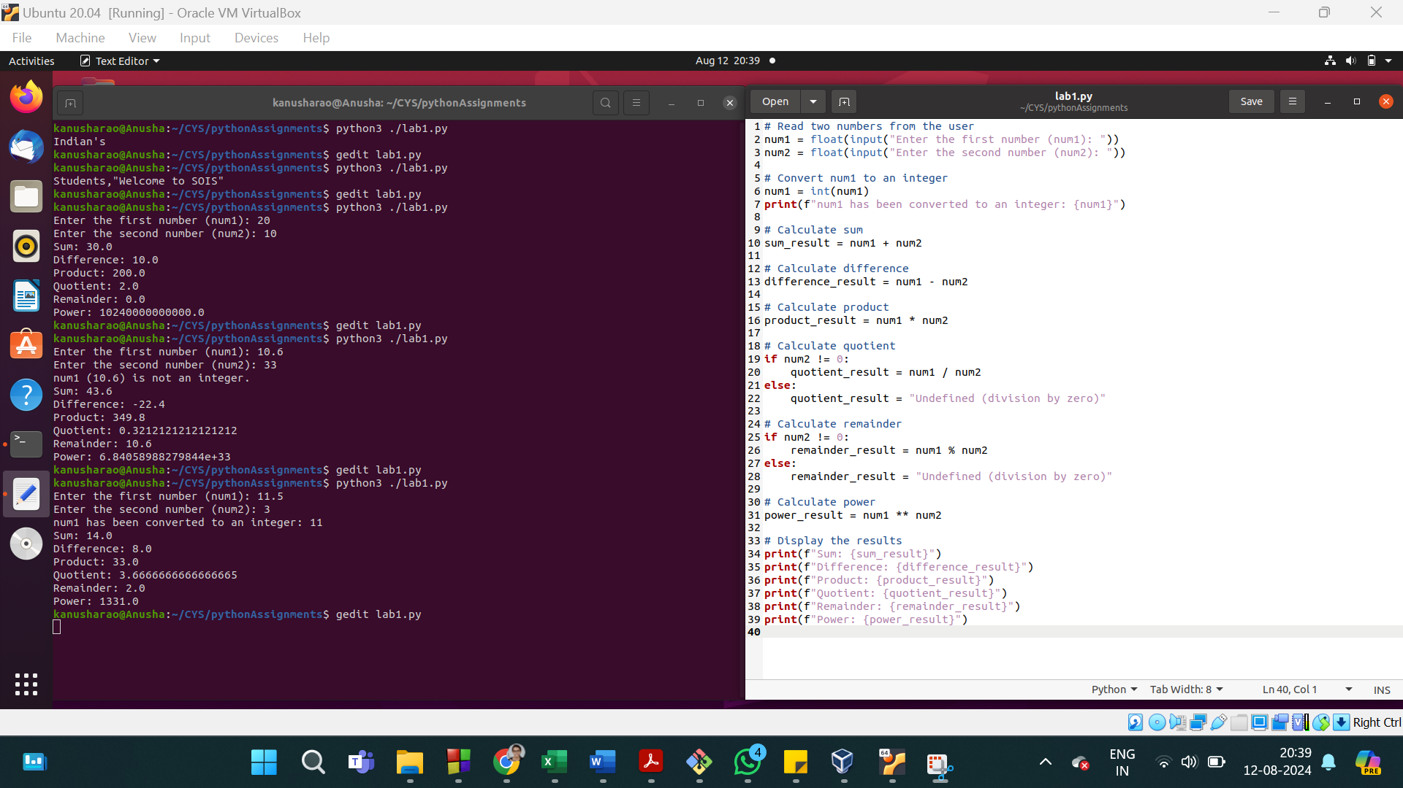

9. Find the datatype for the variable num1 and num2.

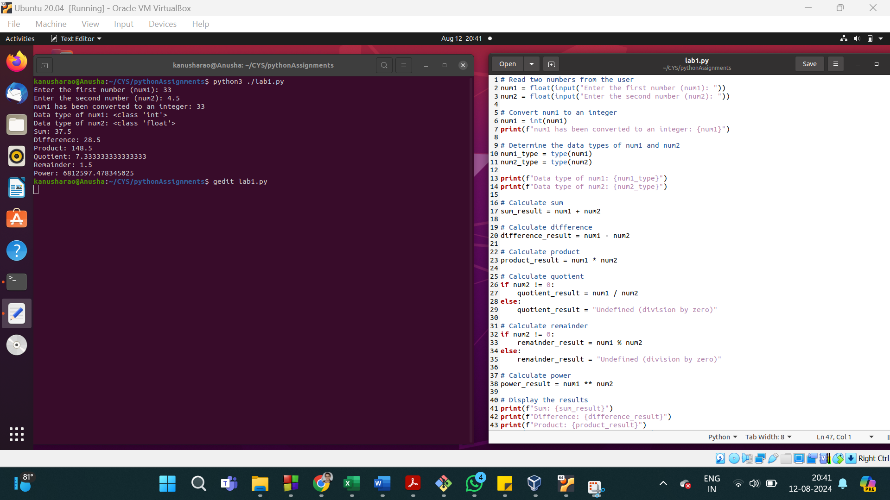

10. read the float value from the user and print the number rounded to 2 decimal places

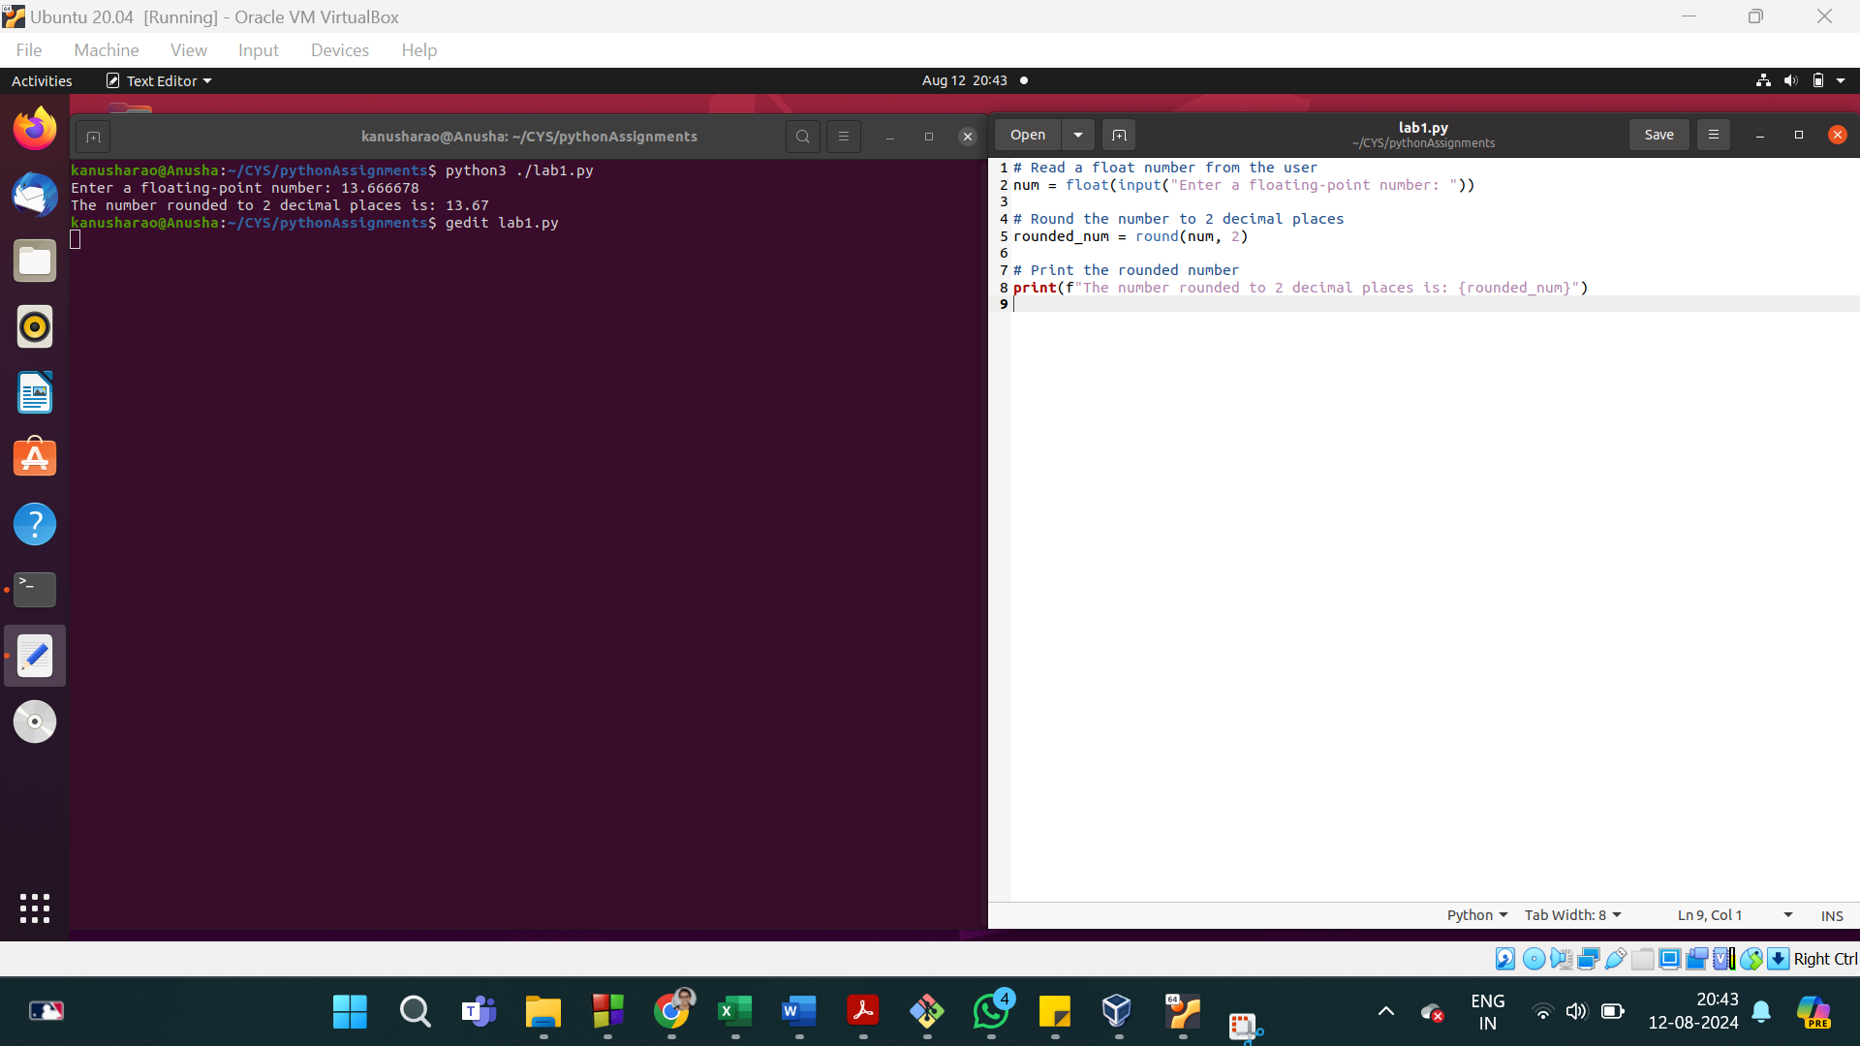

11. read the float value from the user and print the absolute value

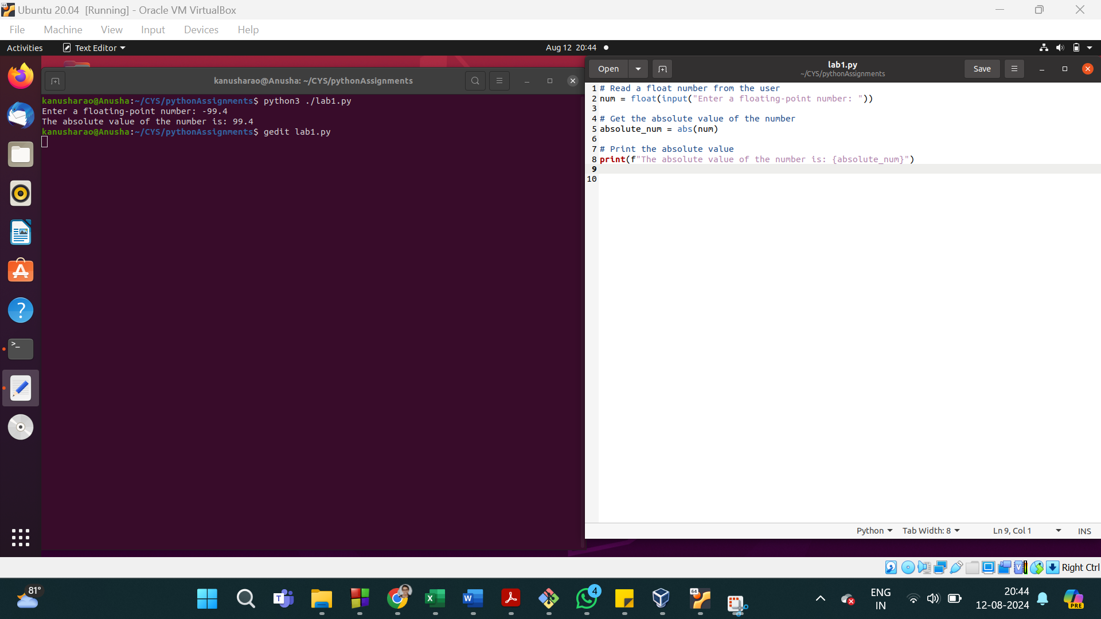

12. Store different type values in the variabale

String

numeric

complex

list

dictionary

set

tuple

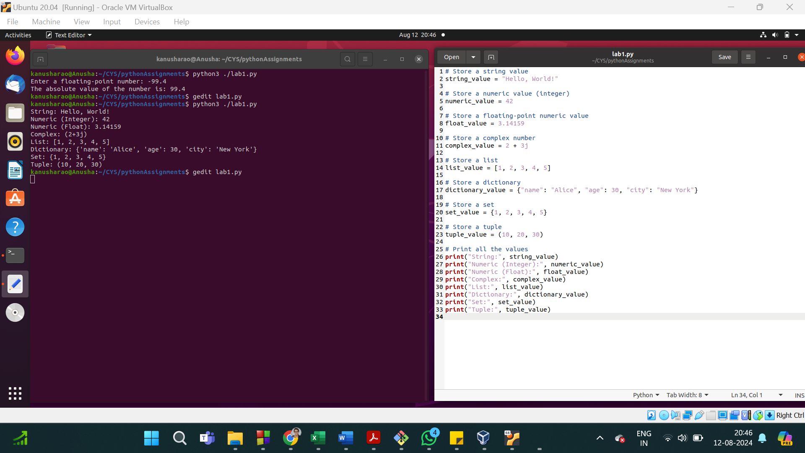

13. Find the data type for the above variables

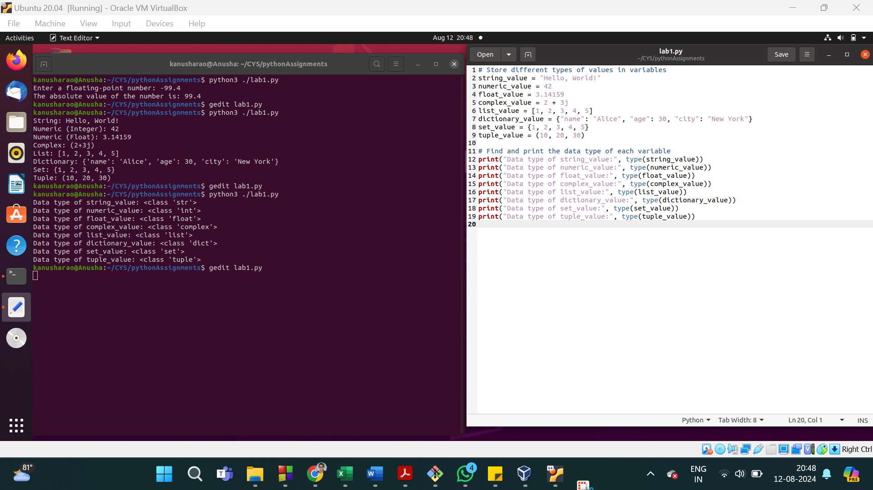

14. # Display the number of letters in the string

greeting = "Welcome to Python Programming"

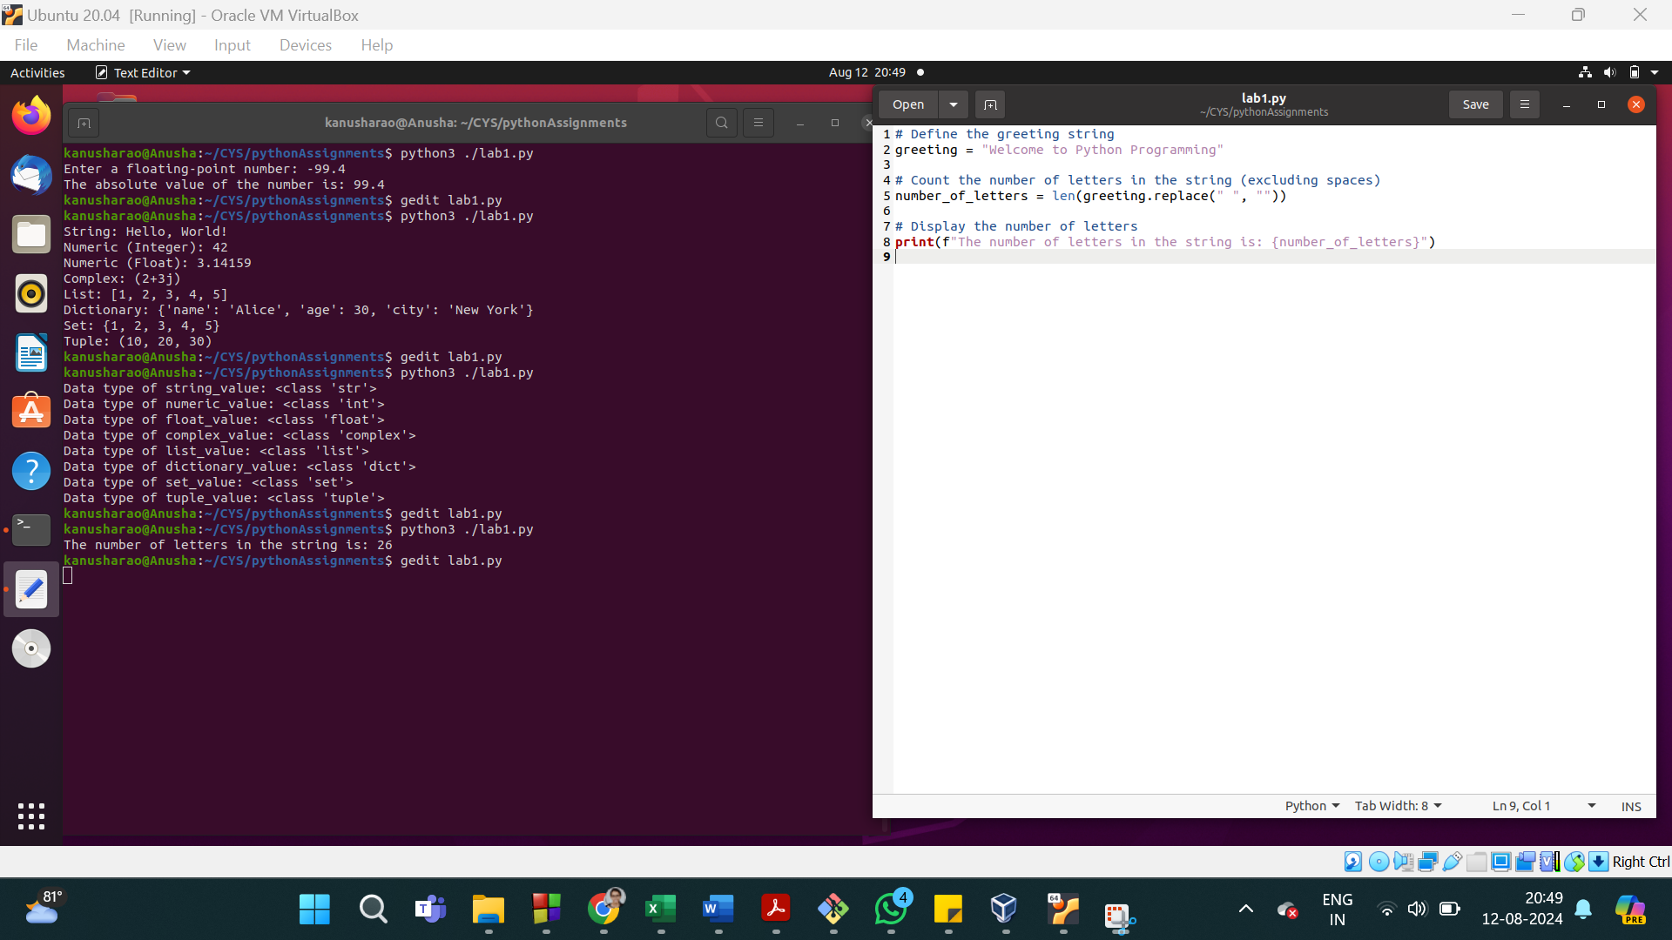

15. read the first name and last name from the user and combine first name and last name. combine name and greeting message

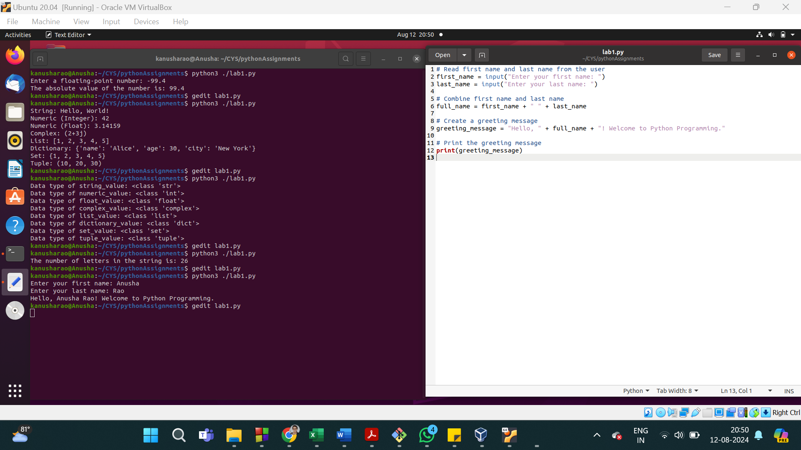

16. Display the string with space

Ex: firstname lastname

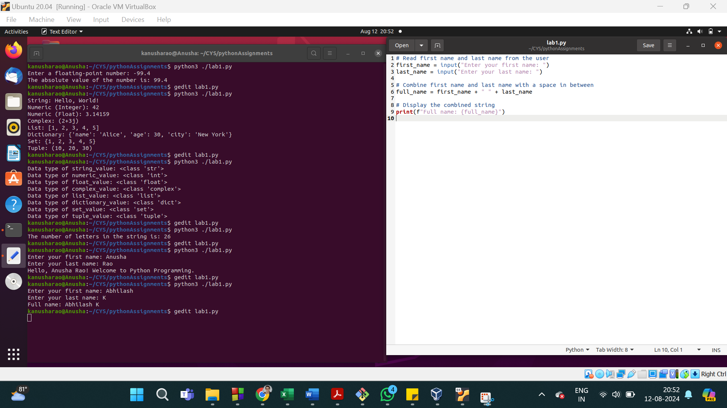

17. Display first two characters from the name

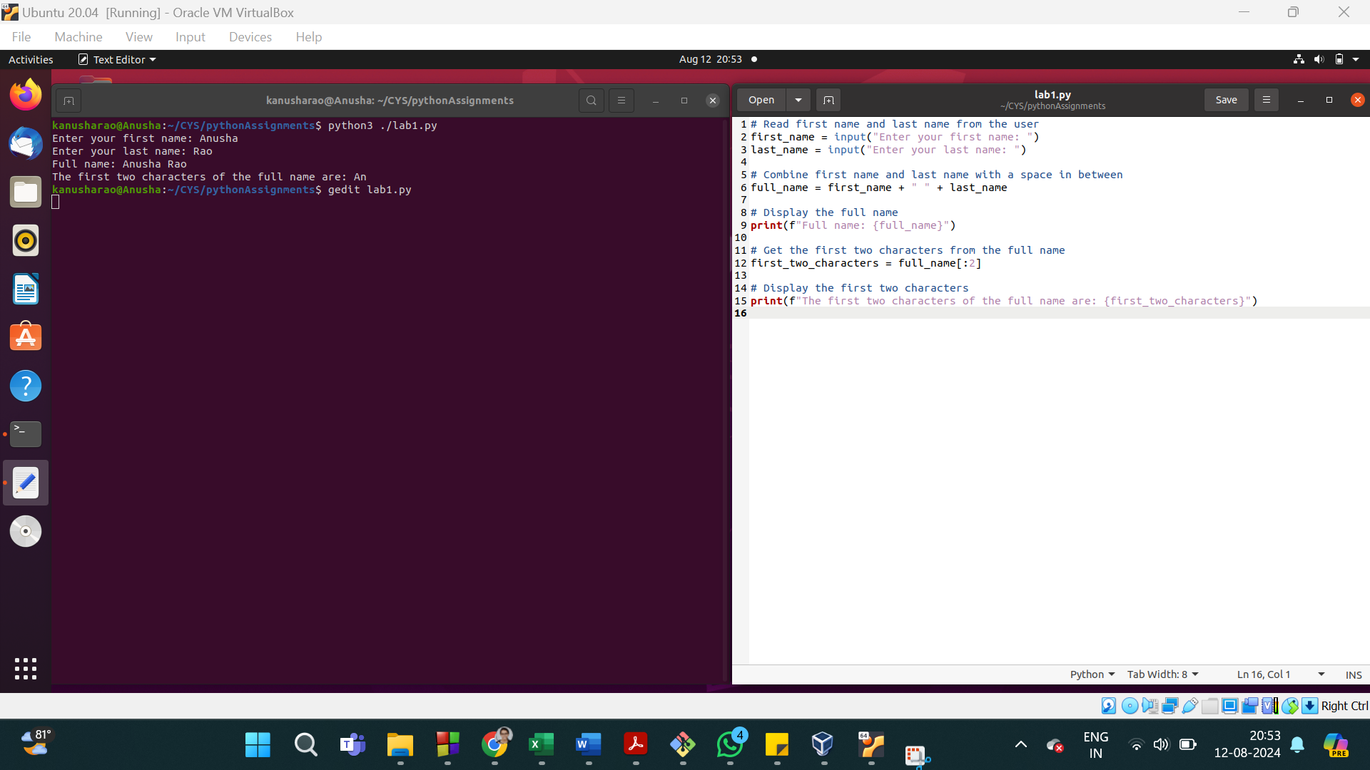

18. Display last three characters from the name

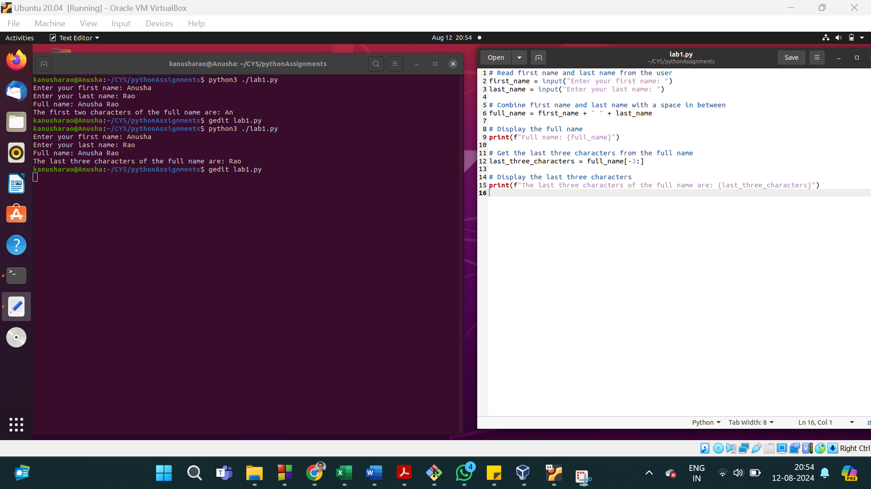

19. Display 3rd character to last character

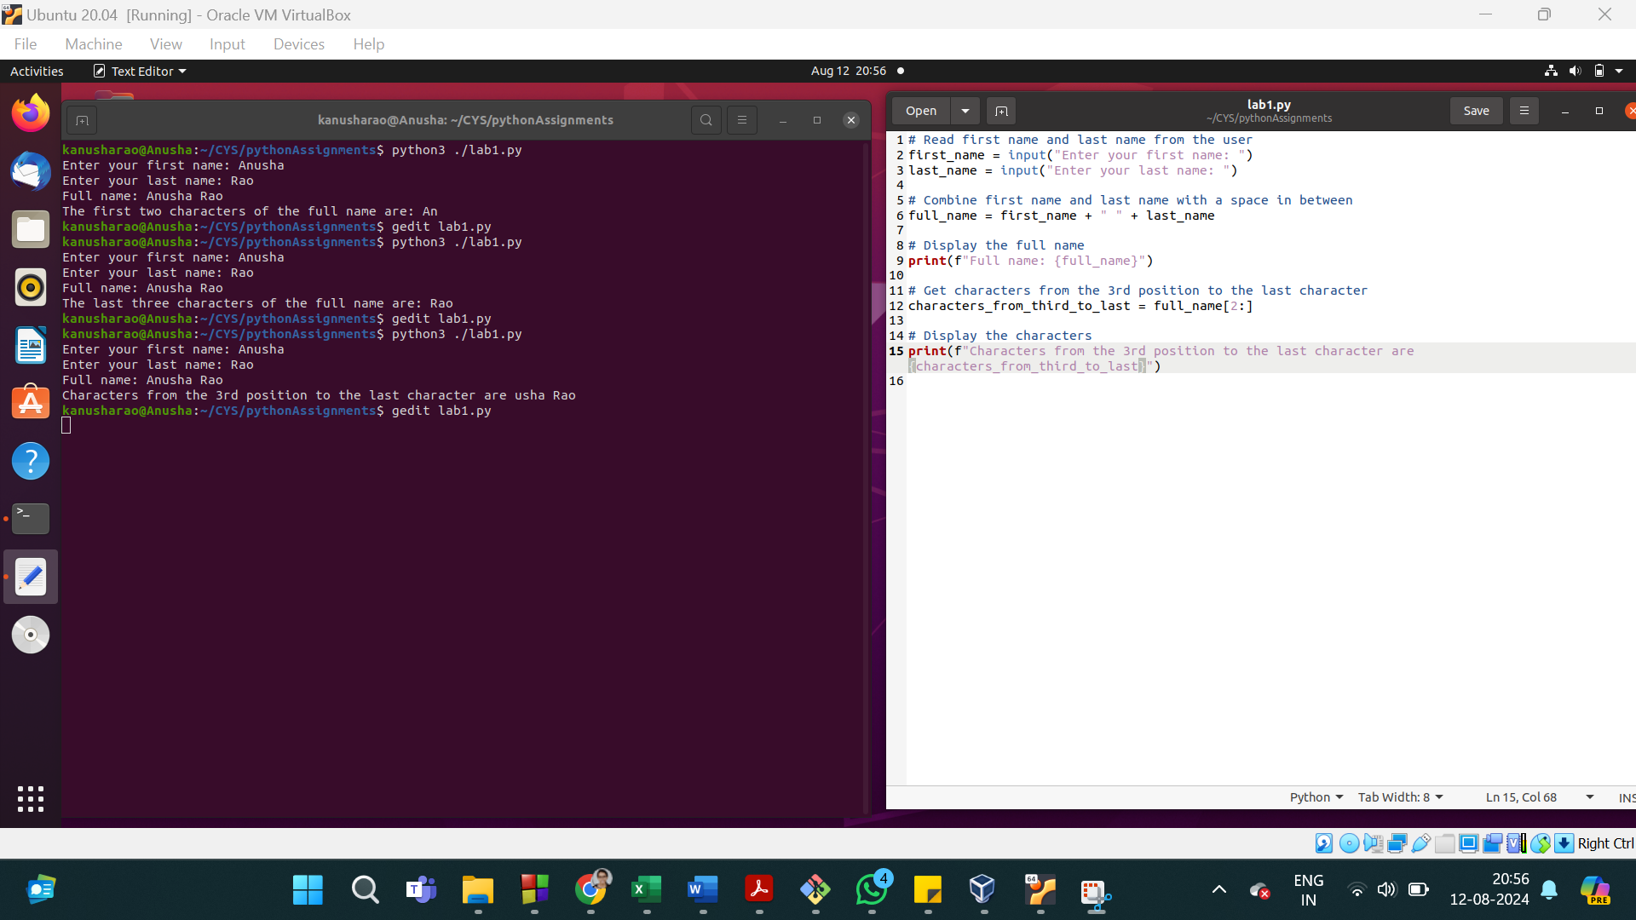

20. Display 3rd to 5th character

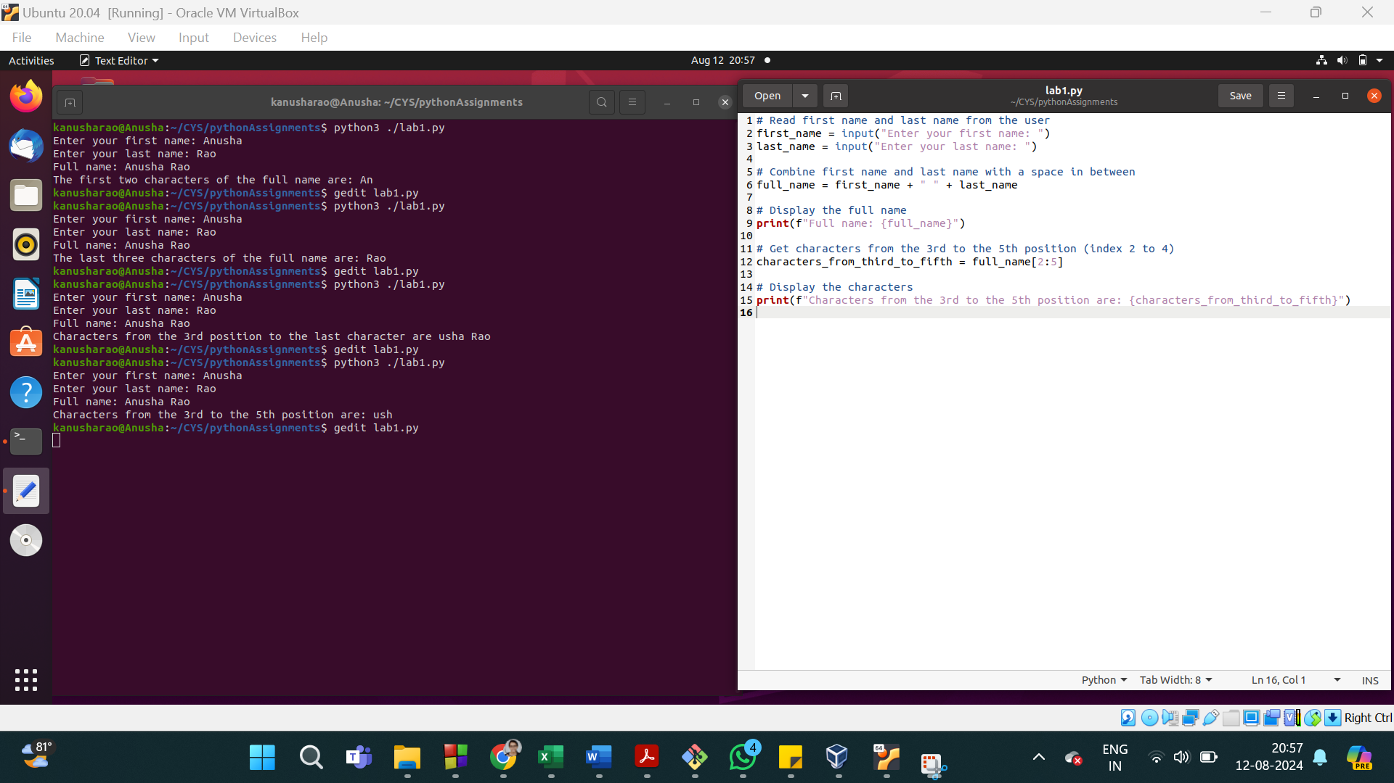

21. Create a list of food with two elements.

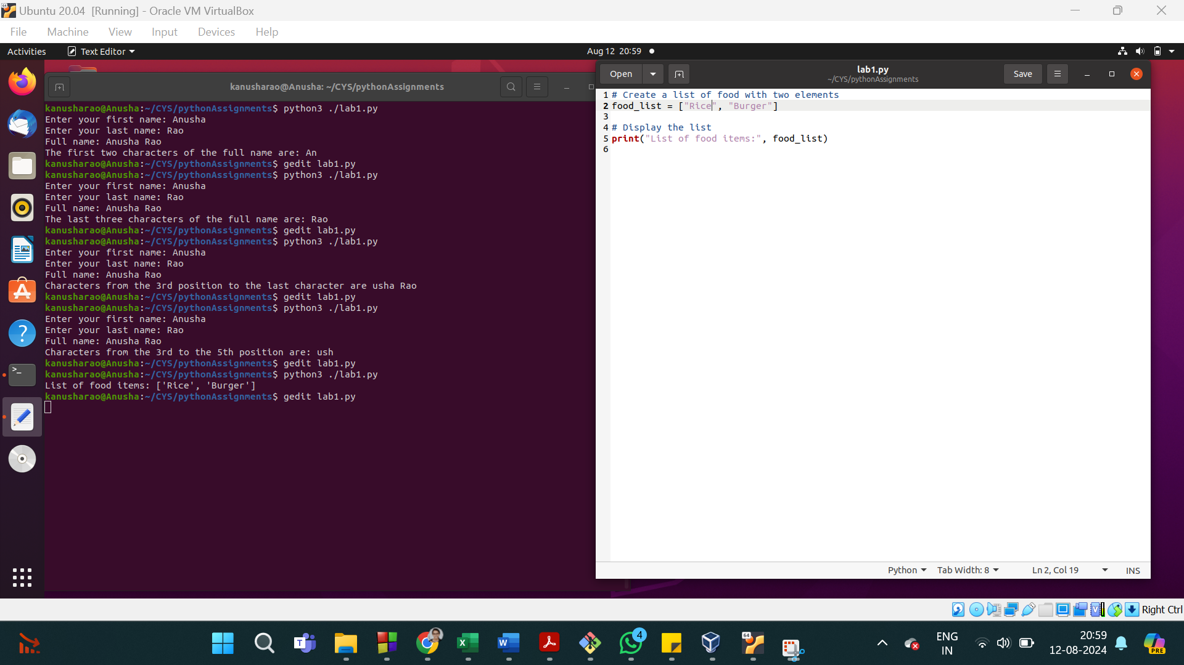

22. Add one more to the food list using .append()

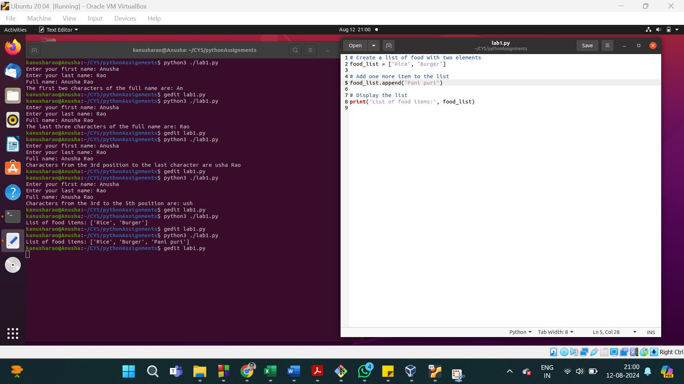

23. Add two more food strings to food using .extend()

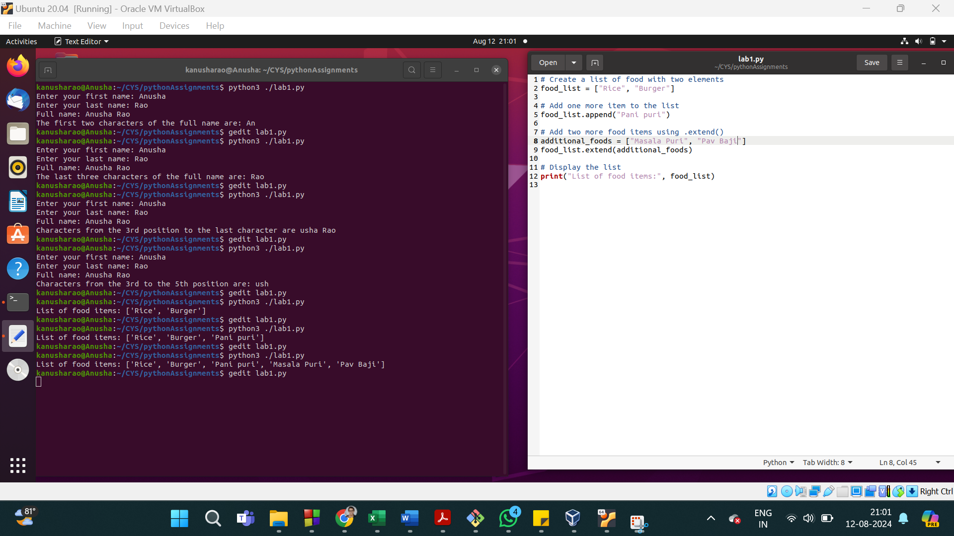

24. Count total number of items in the list

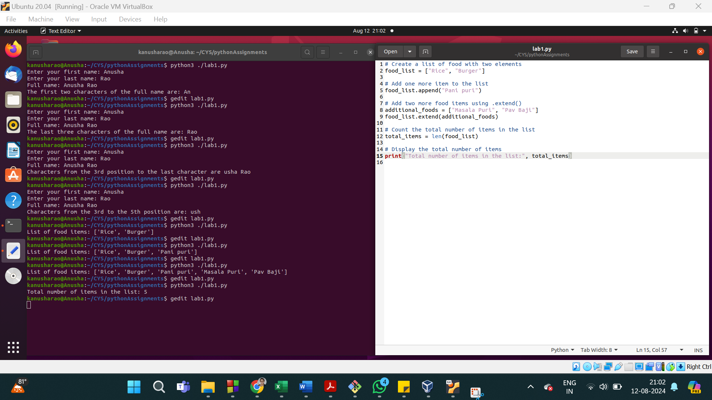

25. Print the first two items in food using slicing notation

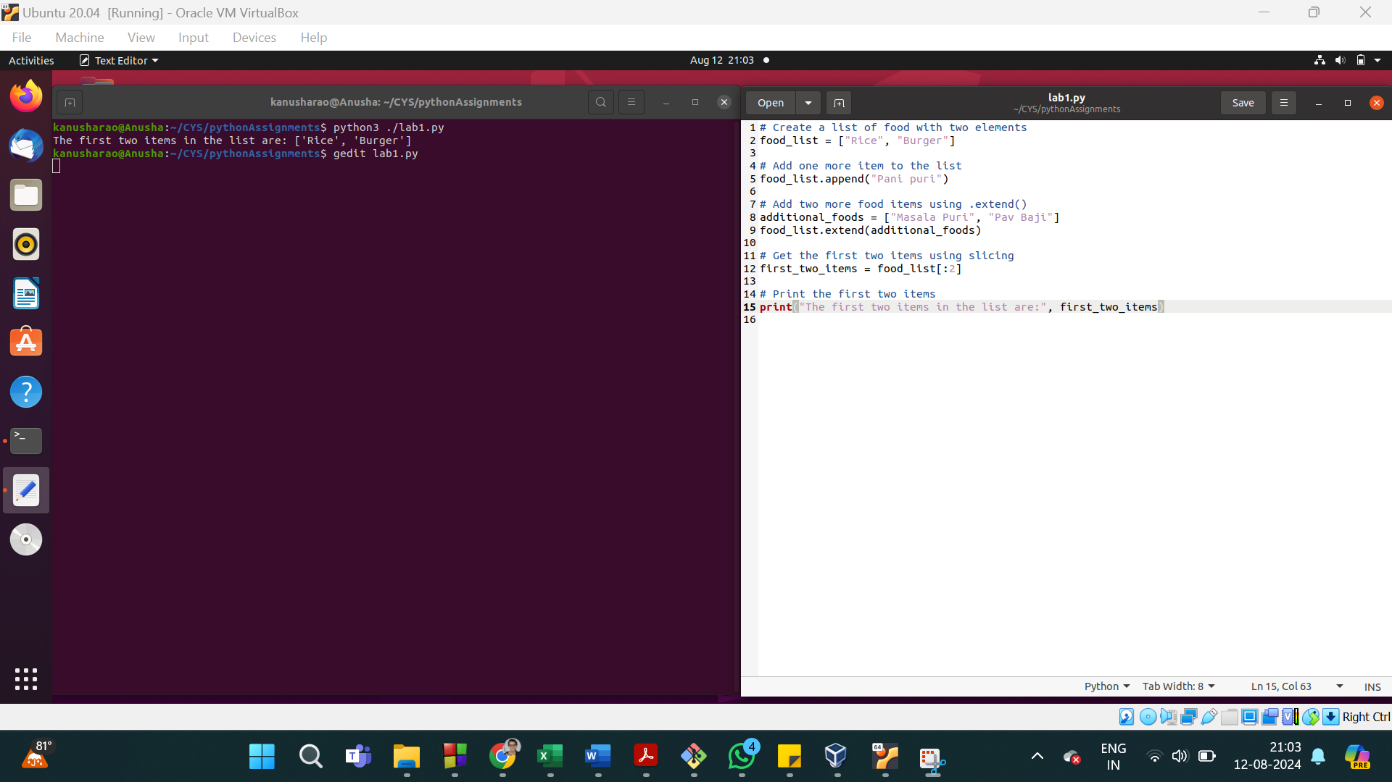

26. Print the last item in food using index notation

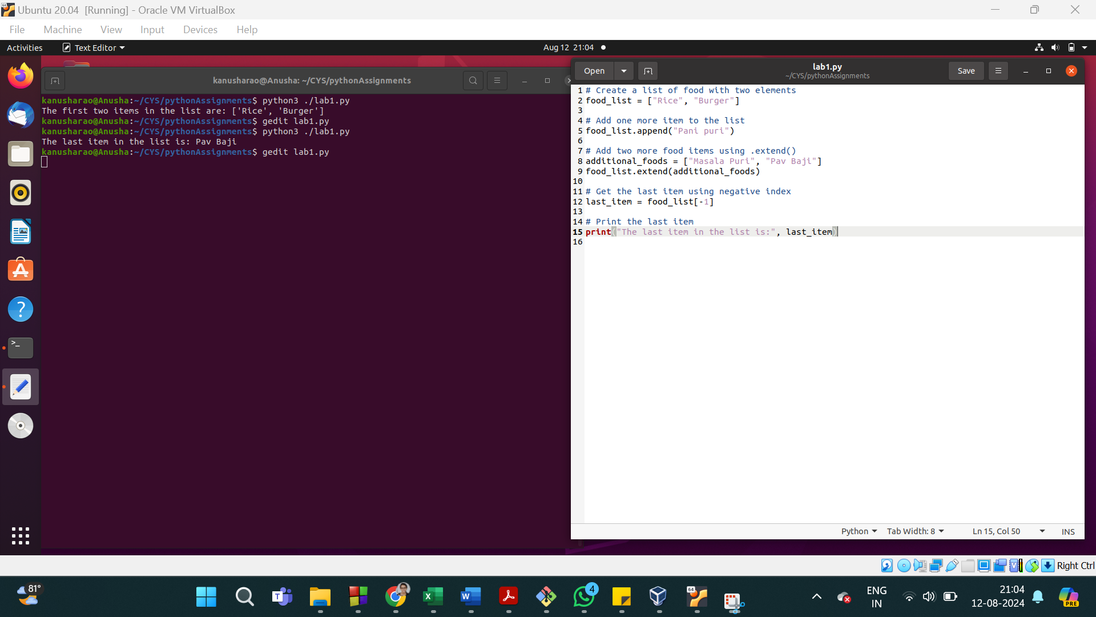

27. Debug: Program is to check the given number is odd or even

number = input("Enter a number: ")

x = str(number)/2

if x == 0

print("The number is Even.")

else

print("The number is Odd.")

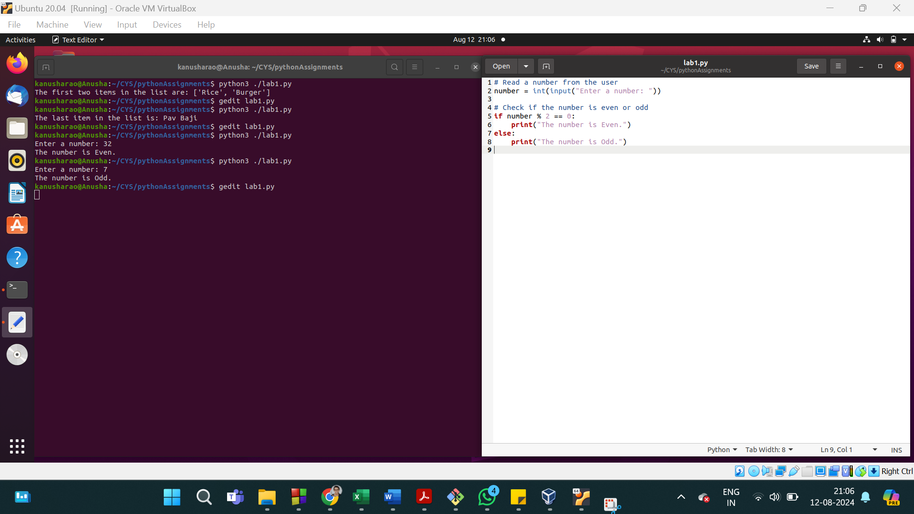

28. Debug: Program is to convert centigrade to Fahrenheit

c = input("Enter temperature in Centigrade: ")

f = 9\*(int(c)/5 +32

print("Temperature in Fahrenheit is: ", f)

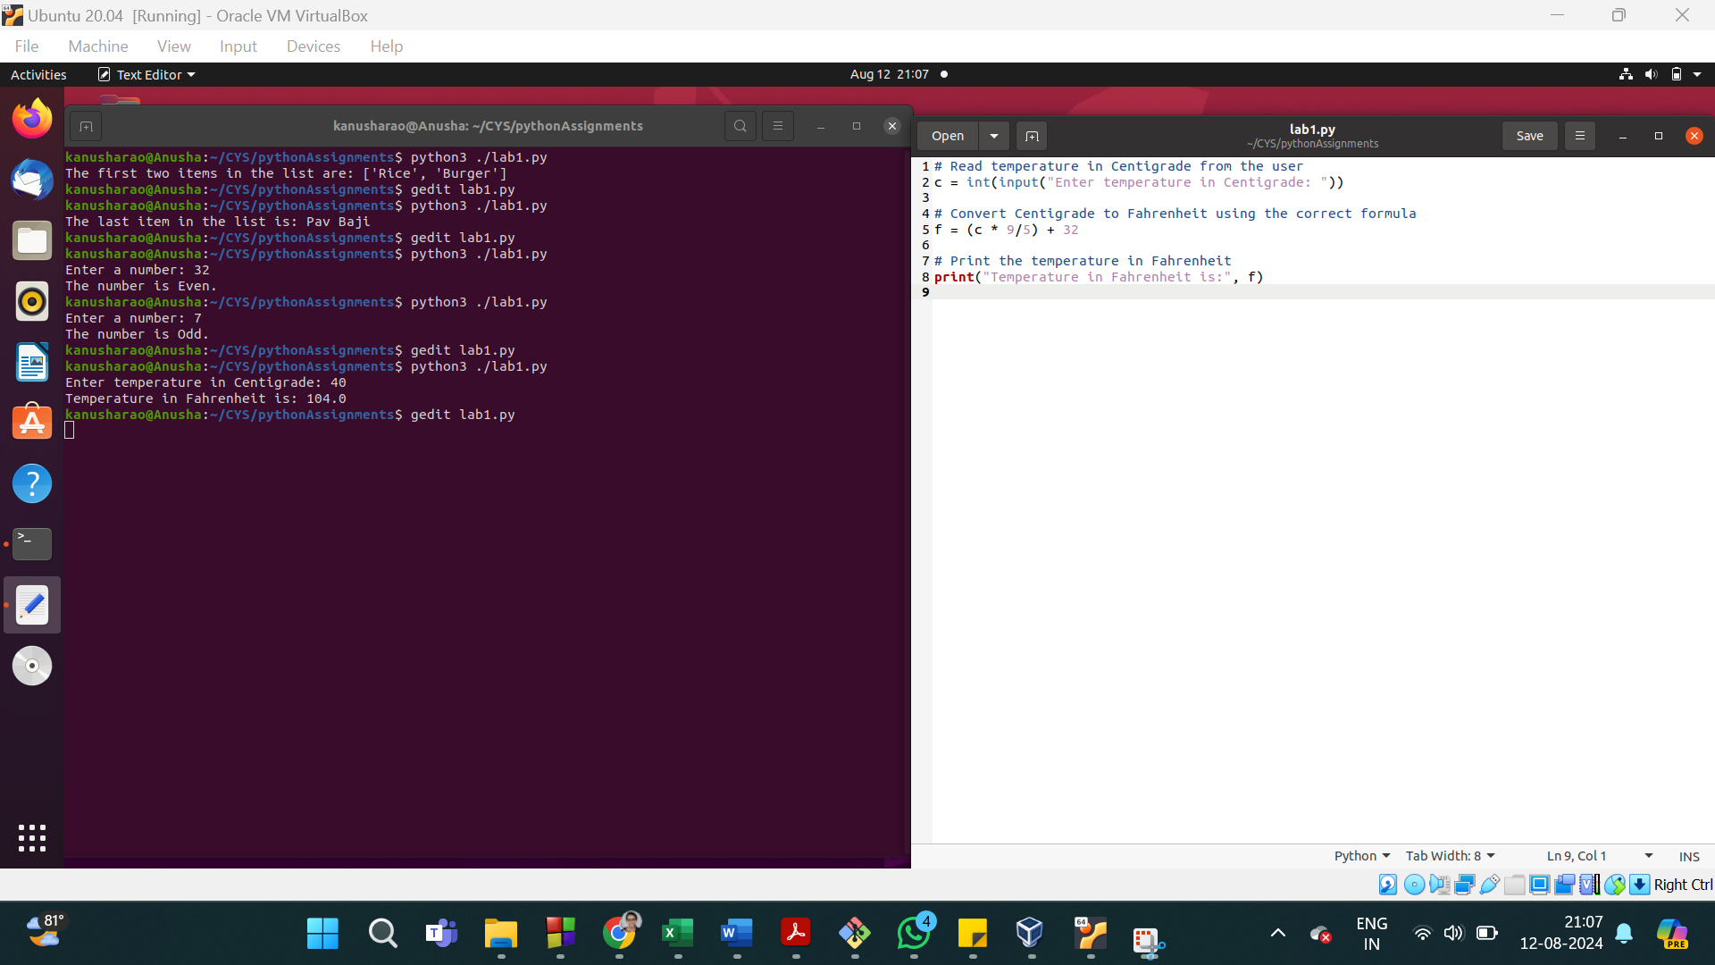

29. Debug:

int = int(input("Enter the count of numbers: "))

i = 0

summ= 0

for i in range(count):

x = int(input("Enter an integer: "))

sum = sum + x

avg = sum/count

print("The average is: ", avg)

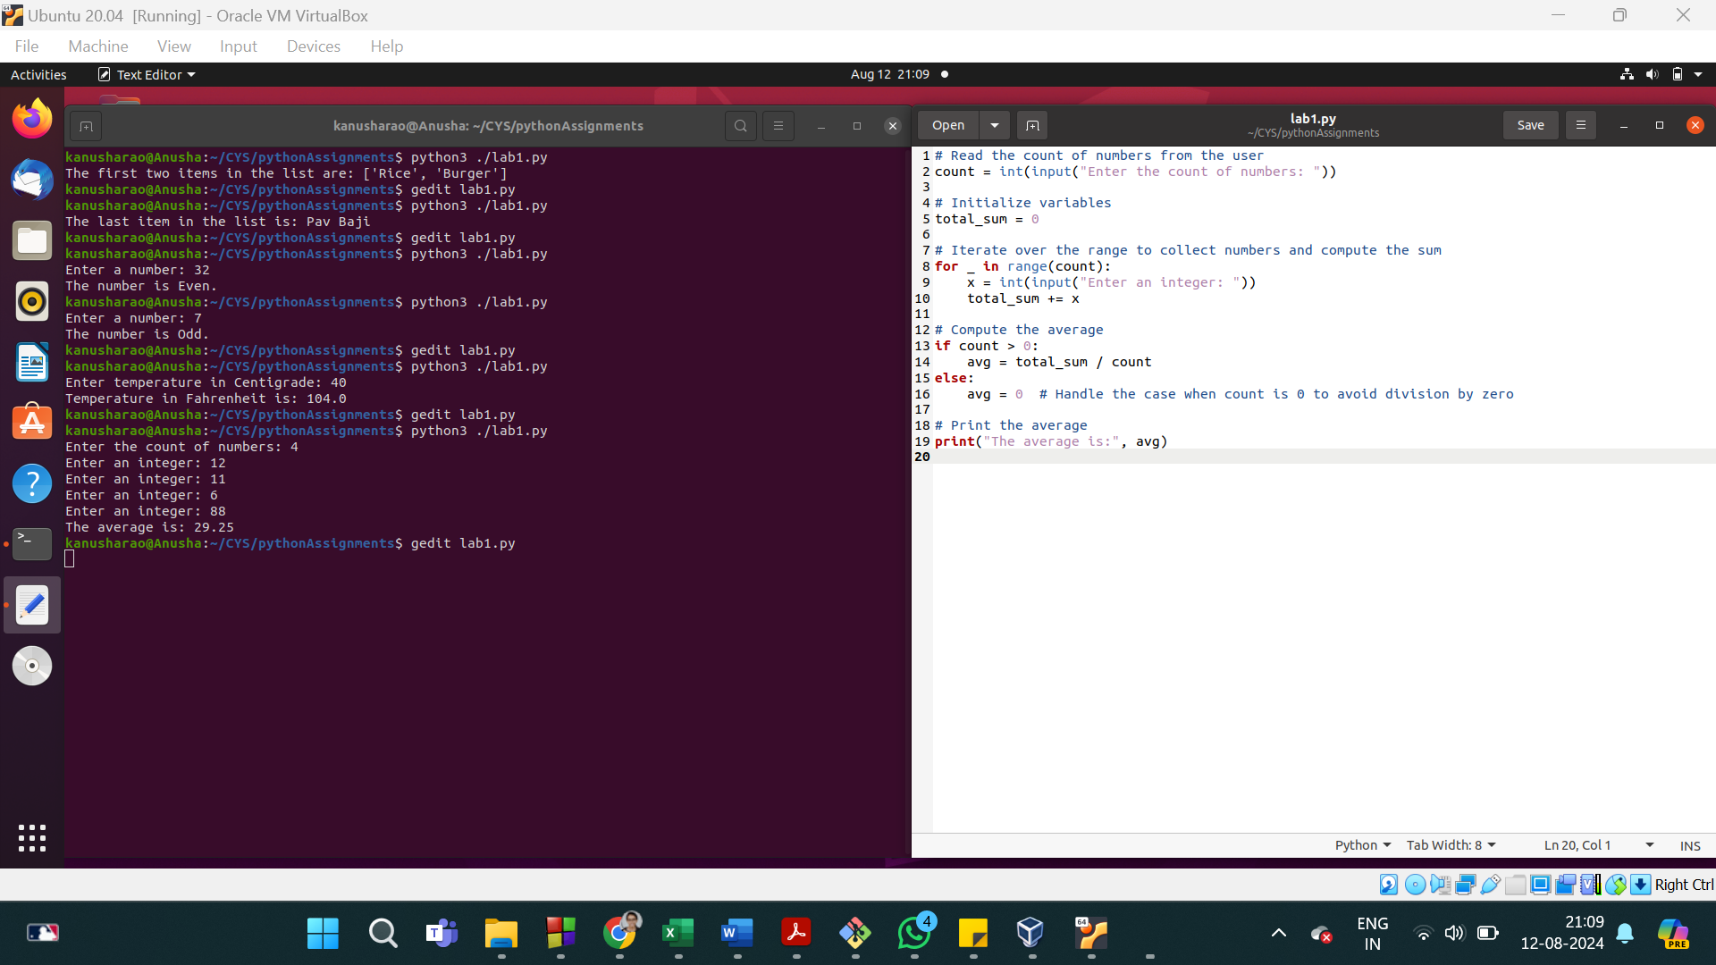

30. Prove : strings is not mutable

lists are mutable

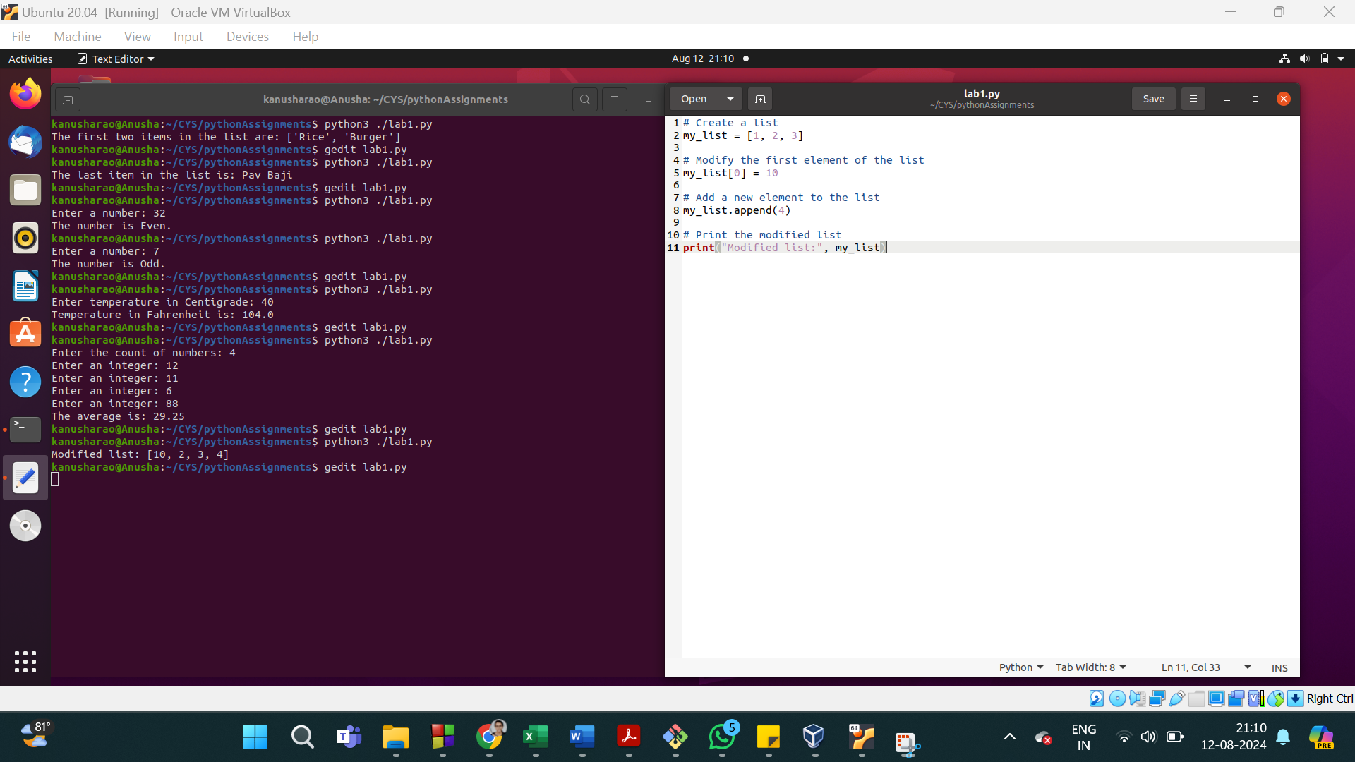

strings is not mutable

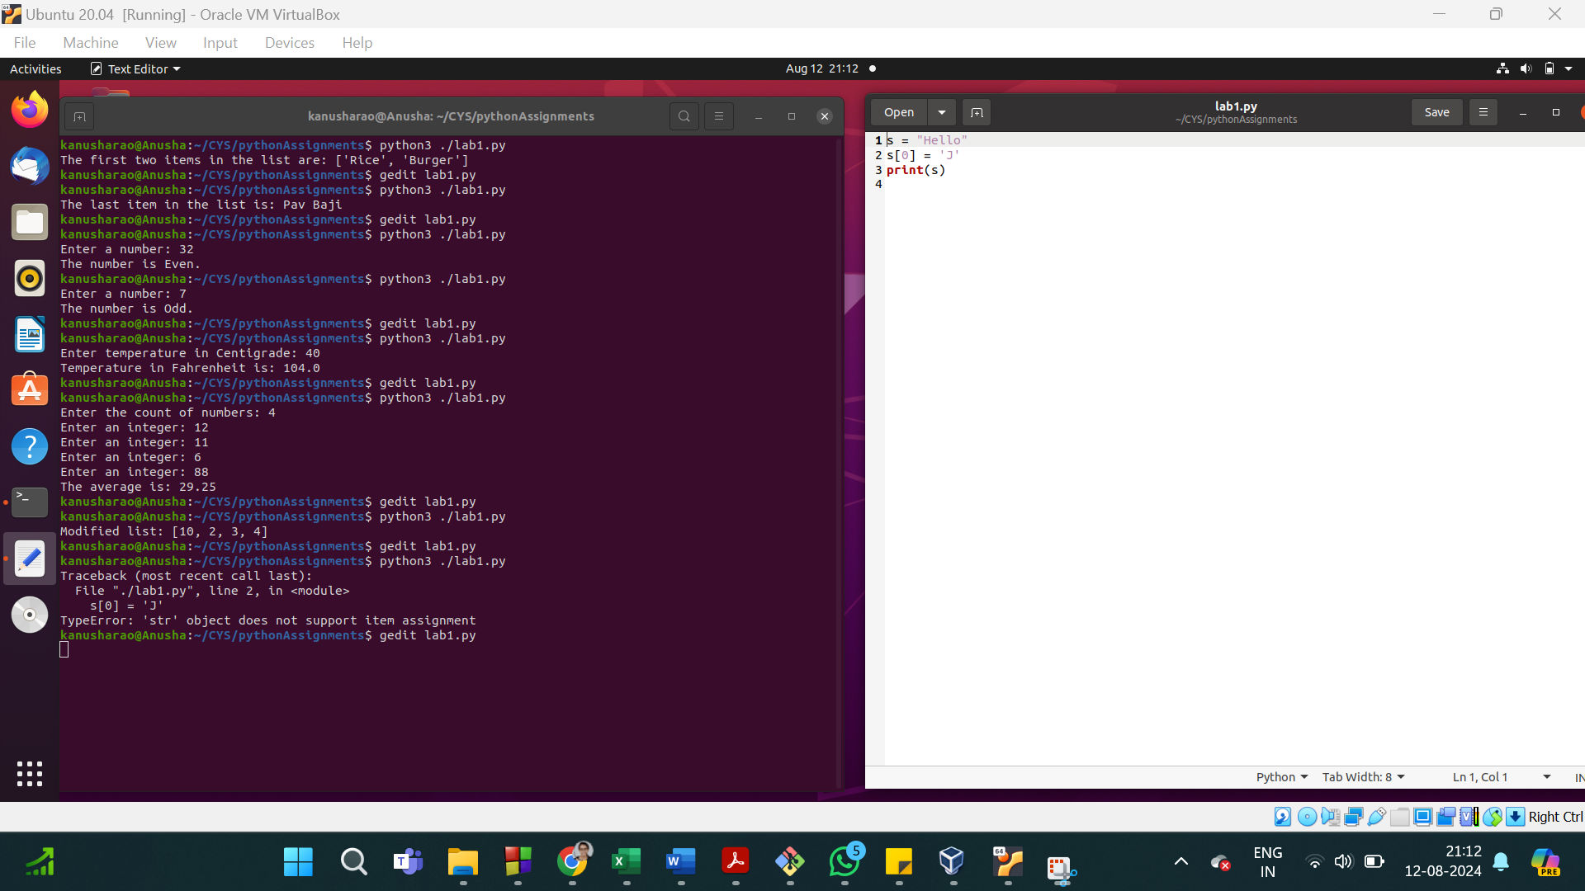

==========================================================================

Deadline 14.08.2024

==========================================================================